
PYTHON PROGRAMMING LAB FILE

Name: Krishna Som
Sap ID: 590025475
Batch: 34
Teacher: Sugandha Sharma

Experiment 1: Python Installation and Basic Python Statements

Objective 1: Installation of Python and Understanding Scripting & Interactive Modes in IDLE

Objective 2: Create a variable to store your age and print its type
Code:
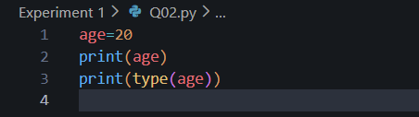
Output:
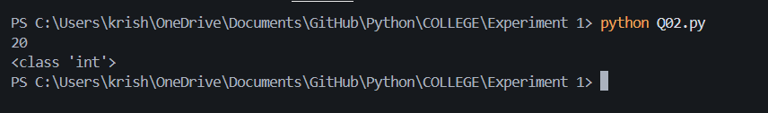

Objective 3: Declare a string variable x and assign value “Hello”
Code:
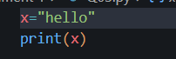
Output:
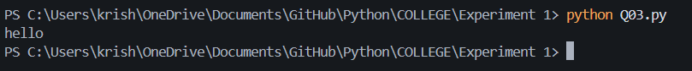

Objective 4: Take different data types and print their values
Code:
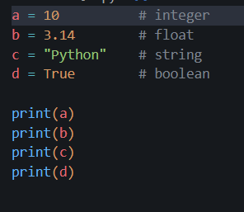
Output:
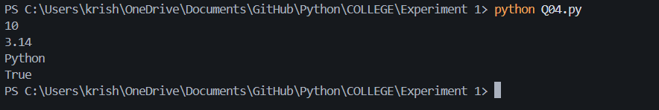

Objective 5: Perform arithmetic operations on two integers
Code:
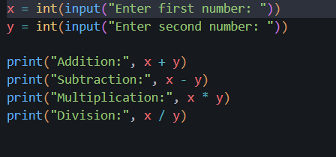
Output: 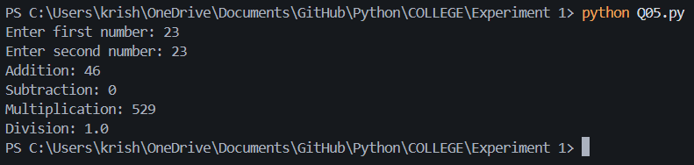

Objective 6: Length of hypotenuse using Pythagoras theorem
Code:
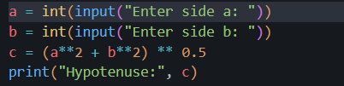
Output: 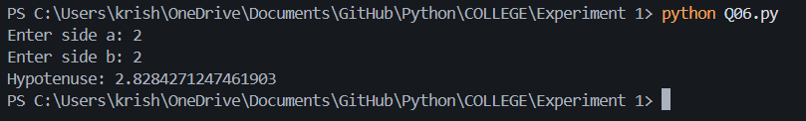

Objective 7: Program to find Simple Interest
Code:
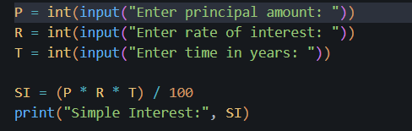
Output:
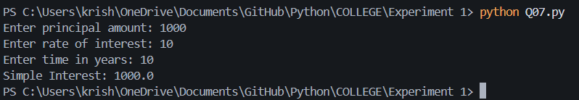

Objective 8: Area of triangle when sides are given (Heron’s Formula)

Code:
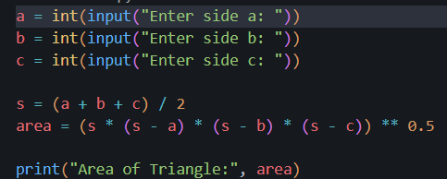
Output:
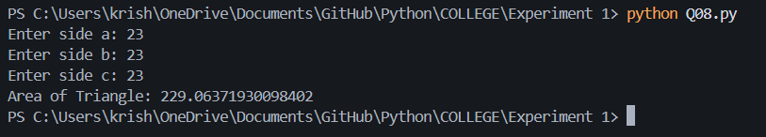

Objective 9: Convert seconds into hours, minutes, and seconds
Code:
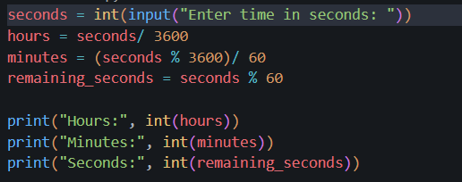
Output:
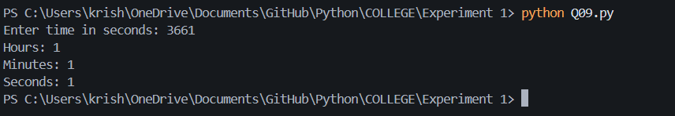

Objective 10: Swap two numbers without using a third variable
Code:
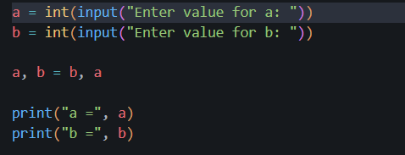
Output:
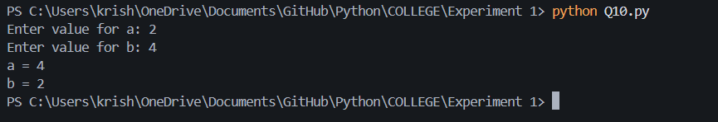

Objective 11: Sum of first n natural numbers
Code:
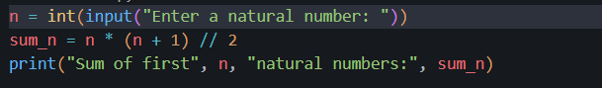
Output:
